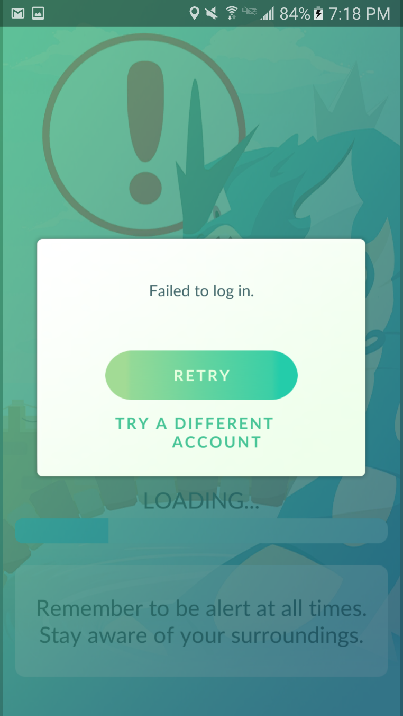Pokemon GO - Day 2 - They broke the game even more 7/20/16

Hey everyone - so Niantic, in all its gaming wisdom, released a patch today, July 20th. I was incredibly surprised, and hopeful. Would it fix some of the game-breakingly bad problems? Not exactly.

Let's start with my log for the day. I did my first pokewalk(tm) at around 9:30 EST, when servers are normally stable. I checked out <https://pokegps.info/go.php> , a cute little app that is accessible from your phone, and tells you where pokemon are currently. Now, it's probably cheating, but whatever. The servers are so awful, and the game is so broken, I feel 100% justified. Regardless, I saw that there were a few pokemon, including a Meowth, which I don't have yet, around my apartment complex, so I set out to catch them!

I walked around the apartment building, then the building, then the next building....and nothing. No pokemon at all. Ok, I thought to myself, the application is probably just wrong. That's fine. I kept going. Then I noticed the little pokeball rotating on the top left corner of my screen. Generally, I guess, it indicates that something is loading. This happened on and off a bit. No pokemon appeared.

Finally, I came to a location around my little 'village' of apartment buildlings that normally has a large spawn of pokemon. Happily, three had spawned! A ratatta, a pidgey, and a weedle. I tried to tap on the Pidgey. Nothing happened. I tapped again. And again. Nothing. Repeat this literally a dozen times. Finally, the game locks up a bit, and the pidgey disappears.

What. The. Hell.

Ok, this has happened to me many times. But it doesn't make it less annoying. So I try the same thing with the Ratatta. This time, the catching screen actually loads after a few minutes, so I toss a pokeball. Splammo! The pokemon gets sucked in.

And the game freezes. I sigh heavily. This, too, I am used to. It happens roughly 50% of the time when the server isn't super stable. I relog, but the game refuses to open, giving me a loading screen which refuses to actually load. It stops at around 20% - see picture below for similar evidence. When this happens, it means, "nope. Try later," OR "reset your phone, Pokemon Go has ruined this session." So, I tried resetting, twice. Didn't fix it.

I sighed heavily to myself, thinking how much of a huge waste of time this was, and all I wanted to do was catch some pokemon. At this point, I have sat down on the curb, in the sun, hoping to catch these three pokemon.

Finally, after about 20 minutes, I reconnect. I do this for the sake of science! I must gather data, and deliver it to others!

I immediately open up my journal in the Pokemon GO program. It tells you whether or not the Frozen-Ball-Pokemon-Glitch has actually netted you a pokemon or not. I'd say about 25% of the time, you get your pokemon. Another 25% of the time, it tells you "Pokemon ran away!" And the remaning 50% of the time, NOTHING. As if it had never occurred.

The journal was blank. I X'd out of it, and tried again.

It took 13 tries for the journal to load.

And guess what? This Pokemon-Frozen-Catching-Glitch was was one of the latter case. No log had occurred at all. It was as if I hadn't ever walked outside. Hadn't waited for 20 minutes to reconnect. Hadn't thrown my pokeball at any of those pokemon.

I then noticed the "Loady-Poke-Ball" in the corner was spinning. Again. I wasn't moving, or anything. I was still sitting on the curb. I had perfectly good reception on my phone. I waited for it to stop, so I could continue on.

But mine didn't stop. It just kept spinning. As I continued walking, it didn't stop spinning. I took this to mean that no pokemon could be detected while it was spinning. I walked around for about half an hour to prove this to myself, and didn't catch a single thing. Didn't even detect a single pokemon. I was getting hot, so I just walked to the pool, put my feet in, and gave up.

An hour or so later, hubby came home for lunch - around 12:00. We went for a pokewalk together. After 20 minutes or so of walking, and intermittent pokeball-loading, we caught one weedle. Ok. So, some days are unlucky. Whatever.

Then the servers went down. I wasn't really paying attention, since the servers were so awful. And Pokemon GO was patched! I logged on, with great anticipation.

But, uh, I couldn't. Because the patch apparently broke the servers.

And guess what? The patch wasn't to fix anything major, either. It was to change some text errors when catching Magikarp. But somehow this broke the servers.

\*heavy sigh\* They've been down for a few hours.

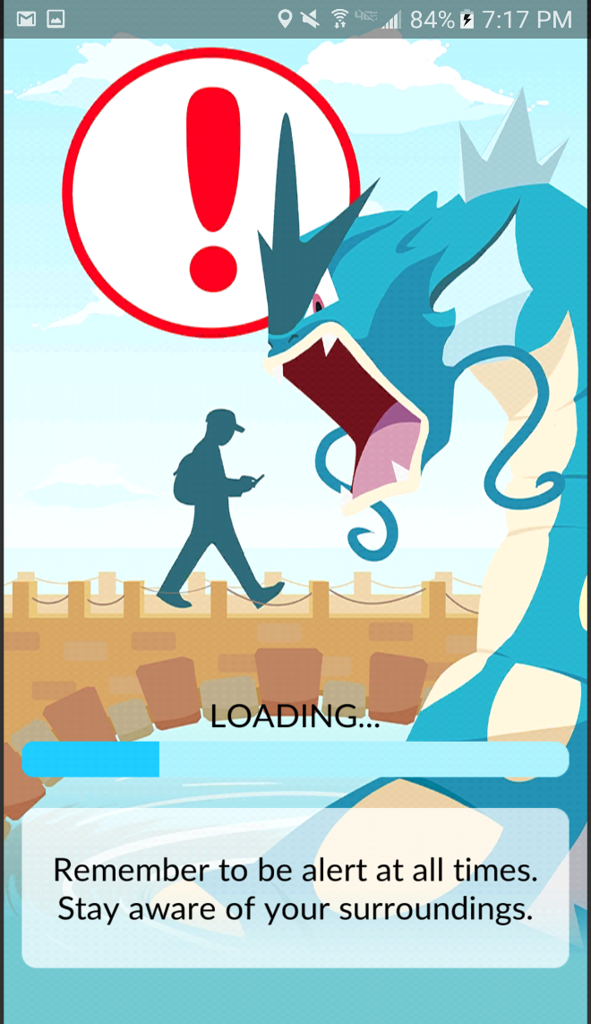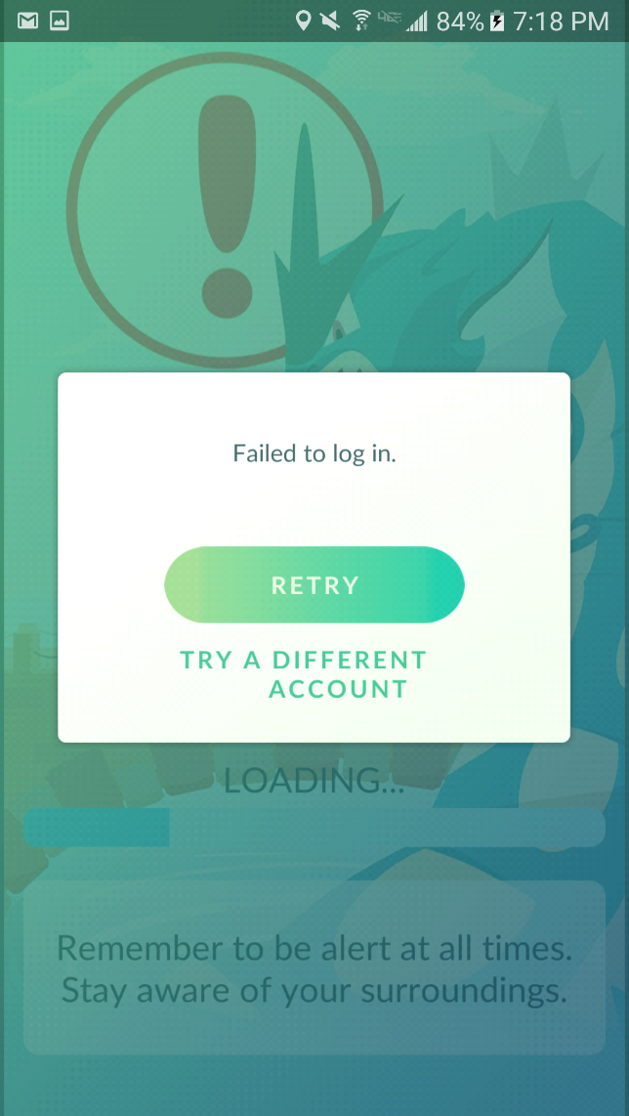

~7:20 p.m. I am so disappointed with this game. I really really want to like it. I do! I understand that launches are difficult for games - most are pretty bad, if you think about any massive multiplayer online game. And I guess they couldn't have anticipated the huge interest in Pokemon GO. Whatever. I give up.

------------------------------------------------------------------------------------------------------------------------

Day 2 Take-away

I caught one Weedle after about an hour and a half of Pokemon GO-ing. The servers were down most of the day. I'm not even left with a feeling of disgust or disappointment today. Just apathy. Maybe if everyone stops playing the servers will get better?

\*apathetically hopeful\* Currently, don't waste your breath. You literally can't even log on right now anyway, so...yeah.